Our annual Friends of Scouting campaign provides the important support to deliver the Scouting program for youth throughout the Central Valley. We encourage you to reflect on how Scouting’s impact in your family and youth in our communities.

Scouts aren’t just camping and getting dirty, they are learning duty to God, duty to Country, duty to others, and duty to self. They are becoming skilled
leaders with great moral character.

FOS funds support quality programs, leadership training, safe camping, youth advancement and facilities. 98% of your gift supports program delivery and 2% administration. All funds stay local and support over 5,000 Scouts in our area.

Friends of Scouting raises over $200,000 annually. Our costs of program delivery have increased 15% in 2019. Our Council has been diligent in operating to maximize donor investments to support 5,000 youth through a lean staff and low overhead. Our annual stretch goal $300,000.

Greater Yosemite Council Friends of scouting

2019 Commemorative Patch
One Scout Sponsors Minimum Pledge $250
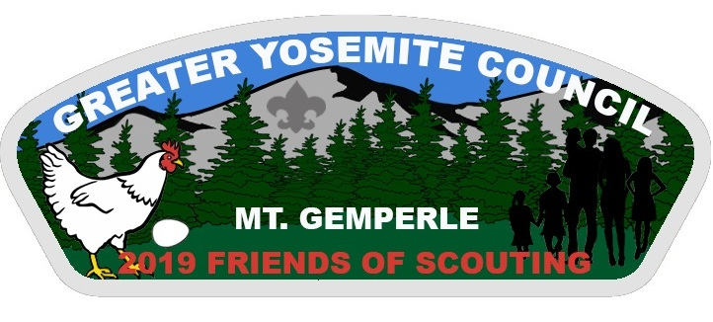

Please also consider an additional one-time gift above your annual gift for a minimum of $1,000 which you can designate to help sustain, grow and invest in our youth in the following ways:

Grow our Endowment

Grow our Capital Fund

Increase Membership & Program Participation

All gifts are appreciated. thank you for your support for scouting!
name____________________________ Address_____________________________________
Phone____________ Email _____________________ (for donor updates only) Unit/District________
ANNUAL FRIENDS OF SCOUTING GIFT
One Scout Tiger Sponsor $250 | Wolf Sponsor $500 | Bear Sponsor $750 | Life Sponsor $1000 | Eagle Sponsor $1,500
I am pleased to support the Greater Yosemite Council, BSA with a 2019 annual gift/pledge of $ _______________
Please invoice me for my 2019 annual gift: ___ 1 time ___ 2 times ____ 3 times ____ Other: ____________
____ Yes, you can count on me for this support annually until I change my gift or withdraw. GYC will confirm annually.

ABOVE AND BEYOND ONE TIME IMPACT GIFT
I will also pledge a one-time impact gift, ___$1,000 __$2,500 __$5,000 Other $__________
Can be payable over 3 years _____ or 5 years____
Please invoice me for my one-time impact gift over _____ years beginning on ____ (year).
My selected area(s) of impact (enter percentage)
___ Growing the Endowment to sustain Scouting in perpetuity for our current needs and ensuring future Scout generations
___ Grow Capital Funds to provide needed maintenance and improvements identified at our facilities
___ Grow membership youth recruitment and increase program participation
___ General Camp and Program impact

Please bill my credit card ___AE ___Visa ___MC ___Discover CC# ____________________ EXP. date ______
Printed Name______________________ Signature__________________________________ Date_______

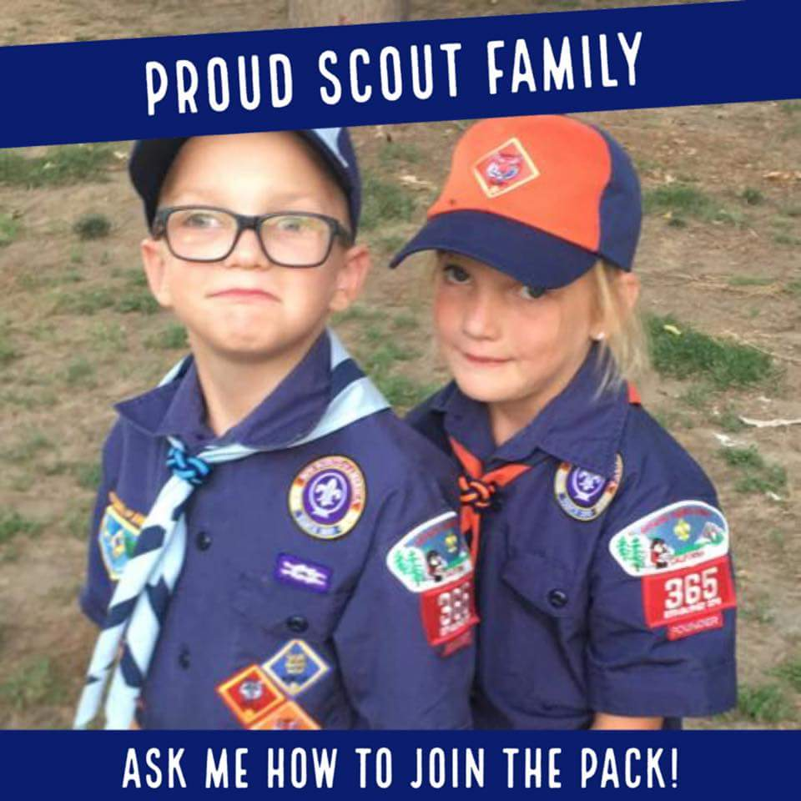
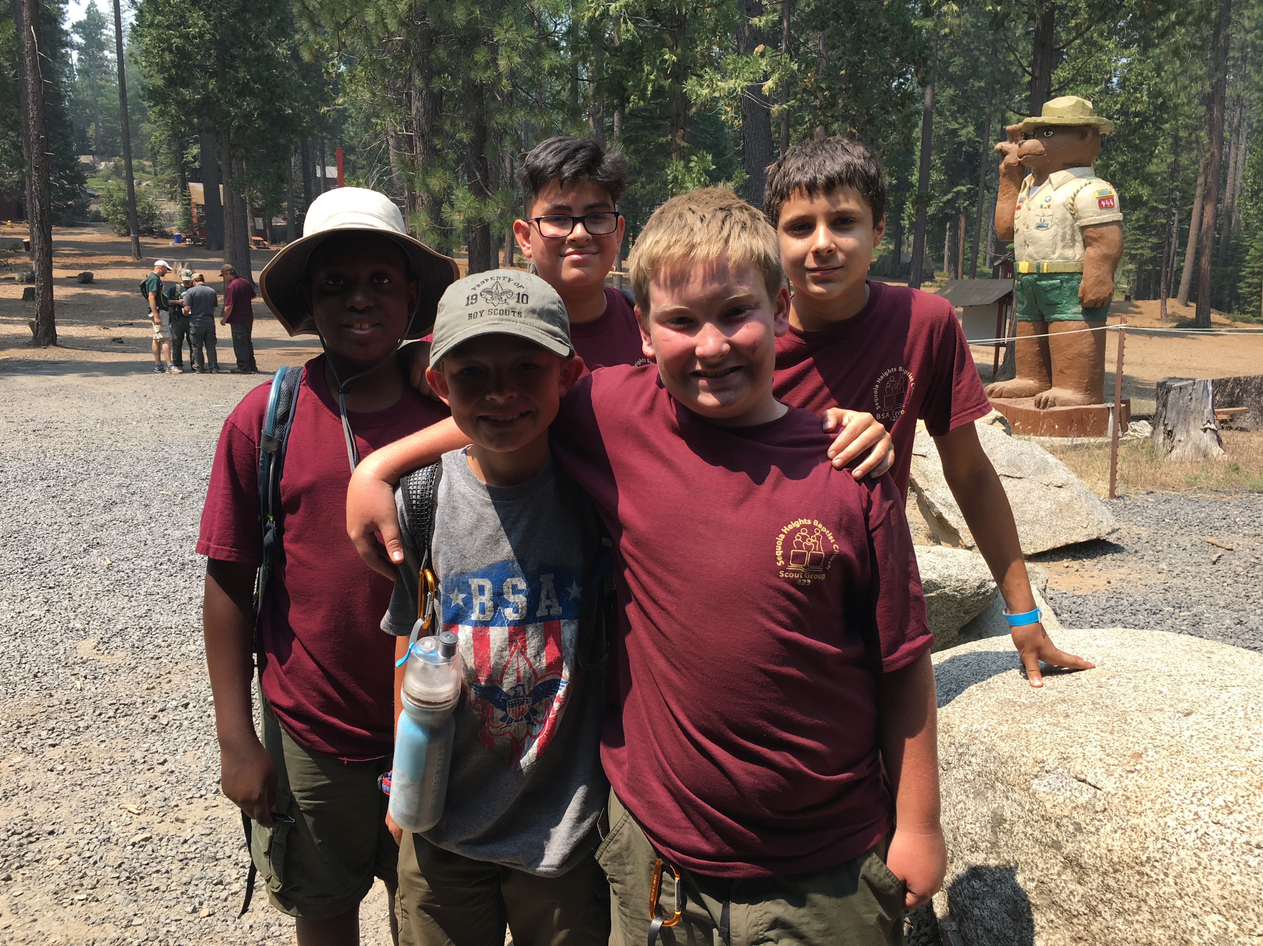
Friends of Scouting…Our Scouts THANK YOU!
Online Giving at www.YosemiteScouting.Org
Why your FRIENDS OF SCOUTING CAMPAIGN support is needed?
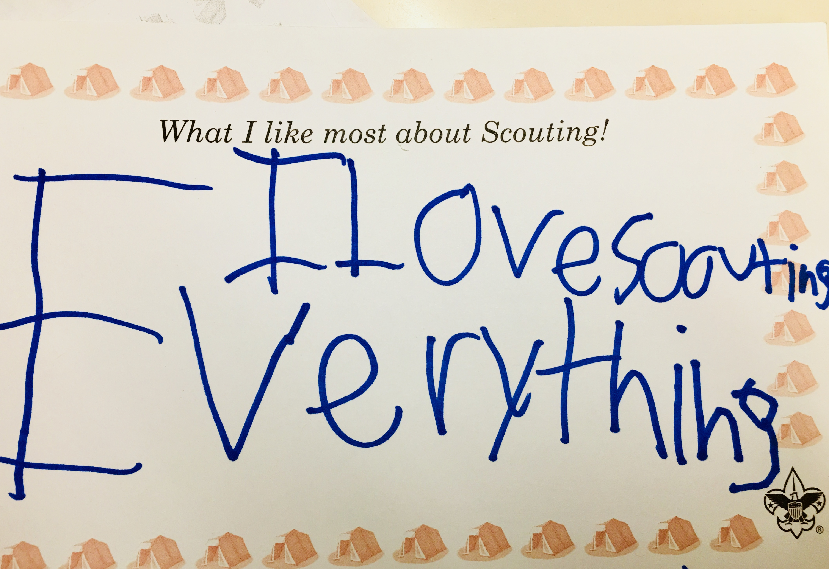
Funds provide support to help volunteers with units, district and council activities, training for adults and youth leaders, and facilities for Scouting.

Friends of Scouting donations are allocated as follows:
- 100% of the donations go directly to Greater Yosemite Council.
- 98% supports Programs, Training, Camp Events, Facilities & Member Services.
- 1% of council revenues support fundraising expenses.
- 1% supports administrative requirements (Audit and Accounting Services).
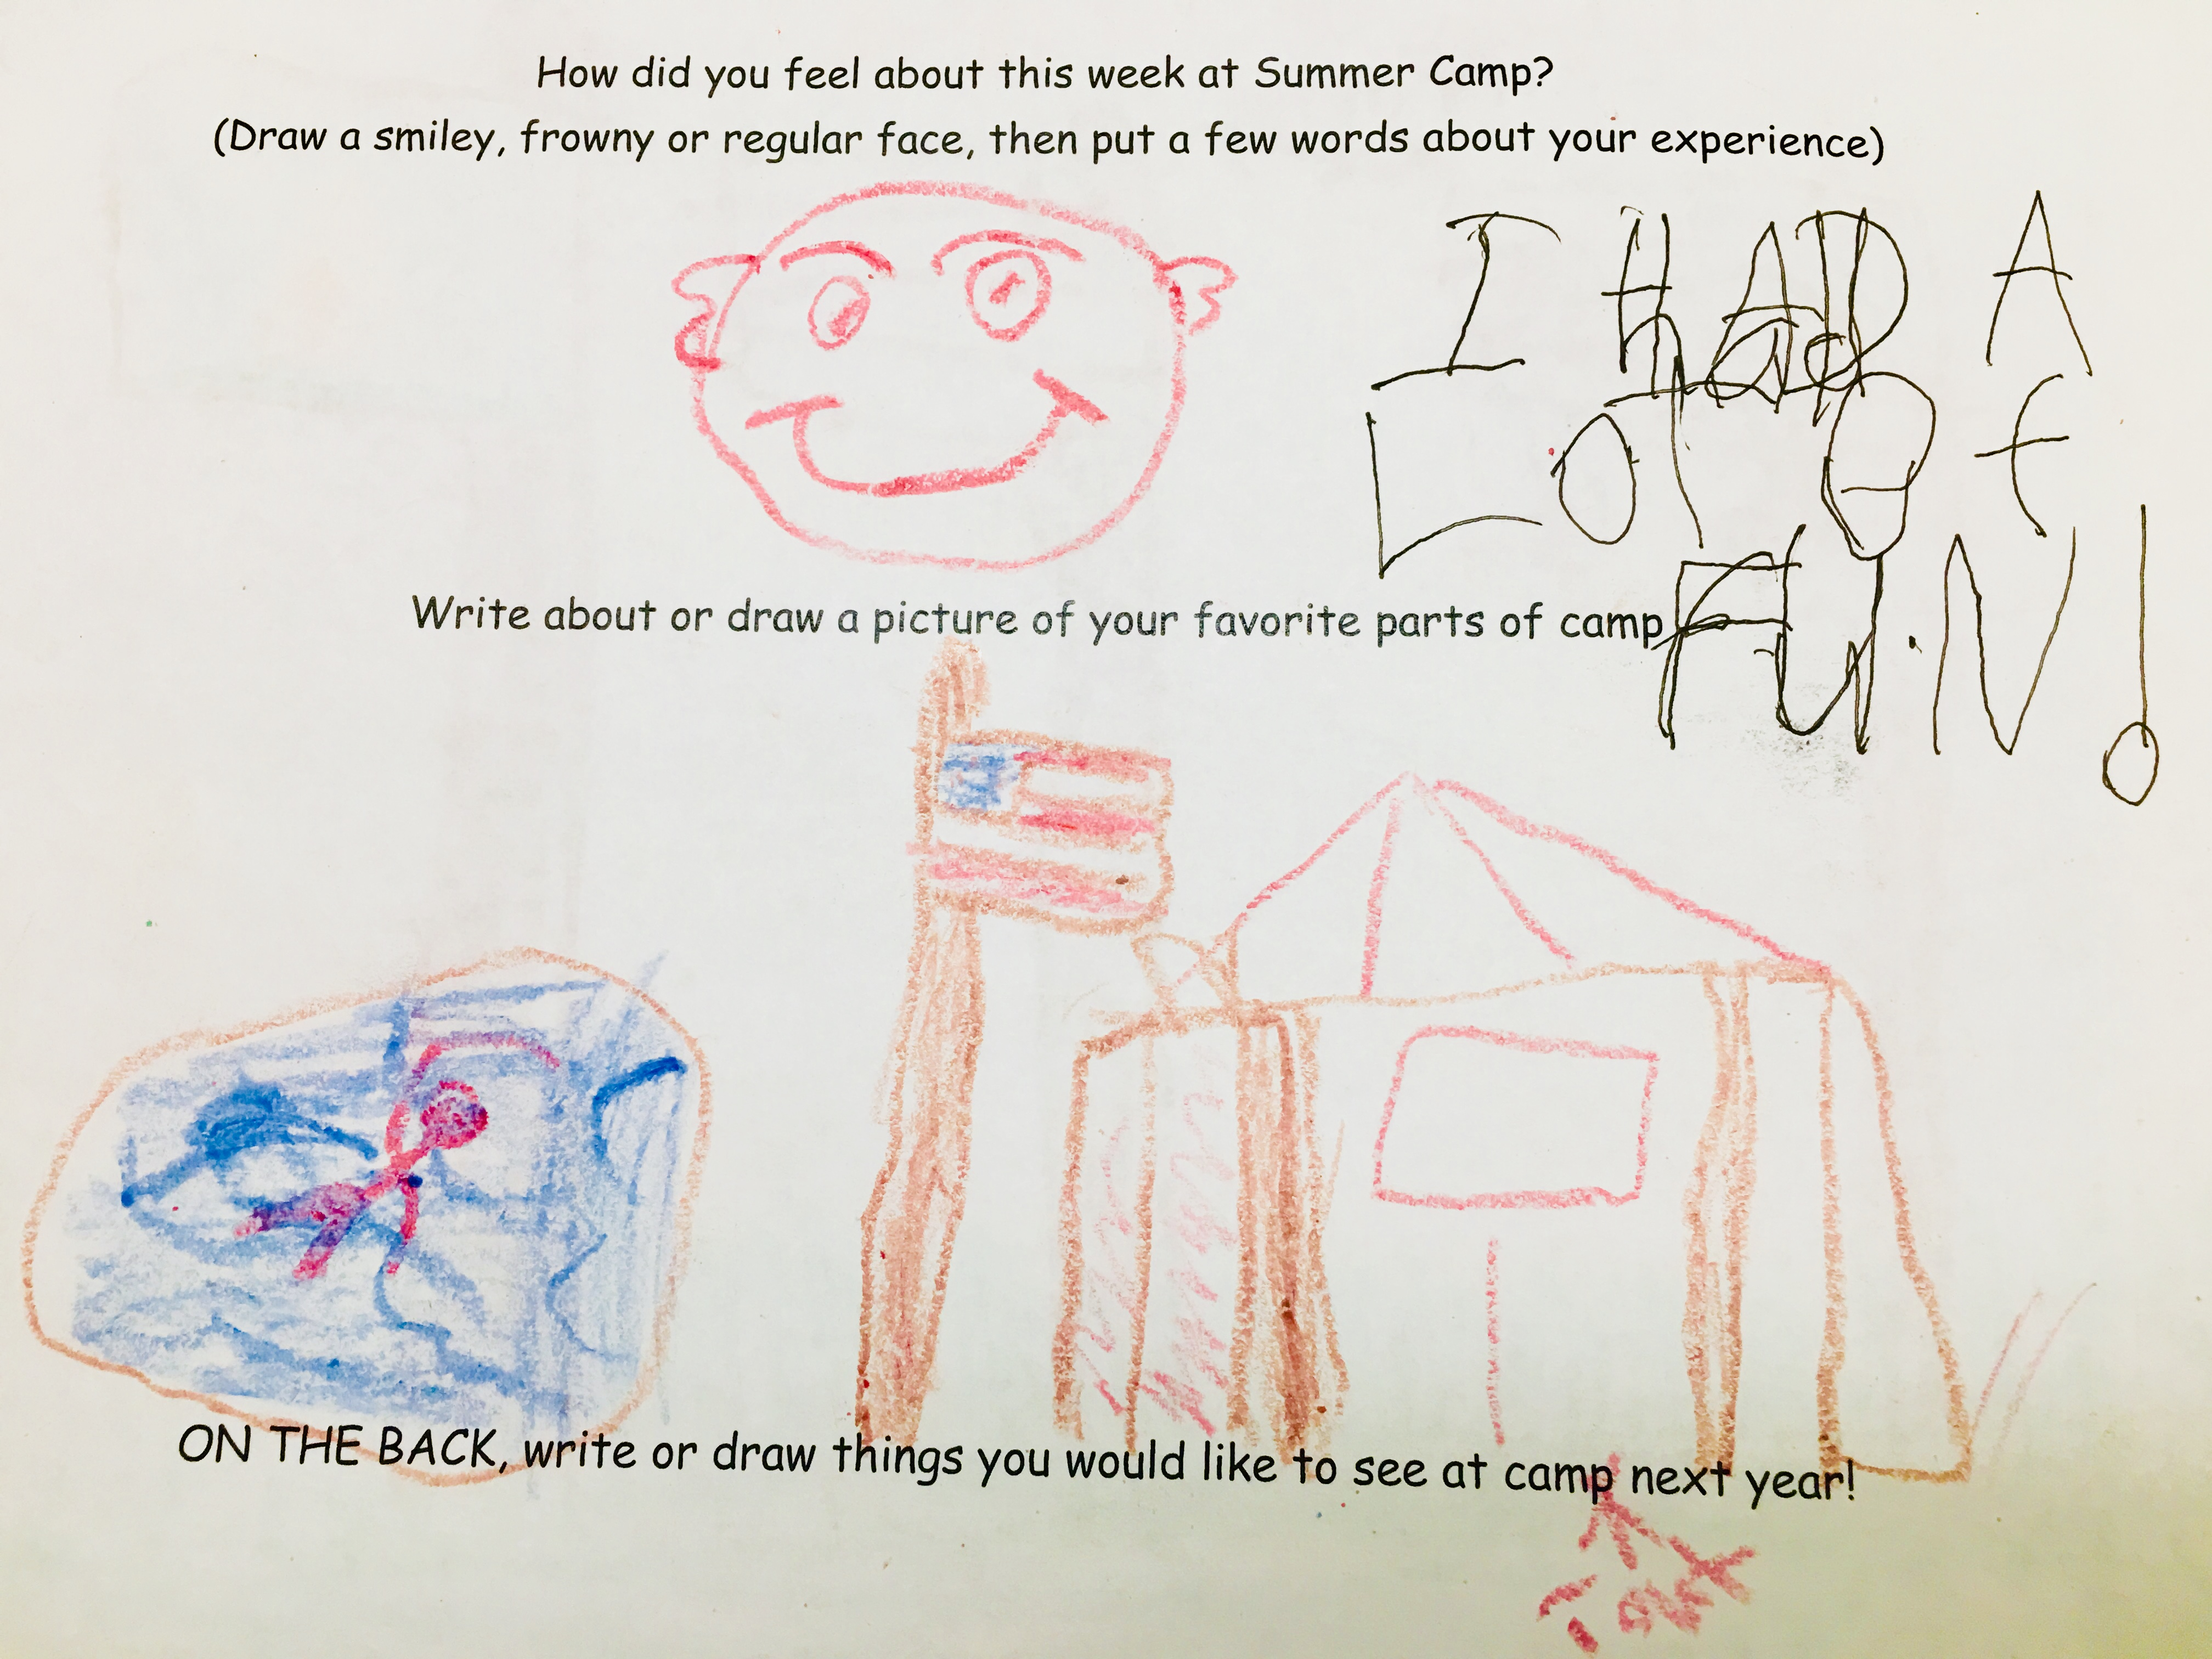
Annual registration Fees and Boys’ Life subscription payments are national fees and not utilized to support Scouting locally.
The Greater Yosemite Council is grateful for the financial support of their Scouting Families and friends. Your support makes it possible to deliver this high value program to your youth. All sized gifts are greatly appreciated. Investments to consider:
One Scout Tiger Sponsor $250 | Wolf Sponsor $500 | Bear Sponsor $750
Life Sponsor $1,000 | Eagle Sponsor $1,500
2019 Commemorative Patch
One Scout Sponsors Minimum Pledge $250
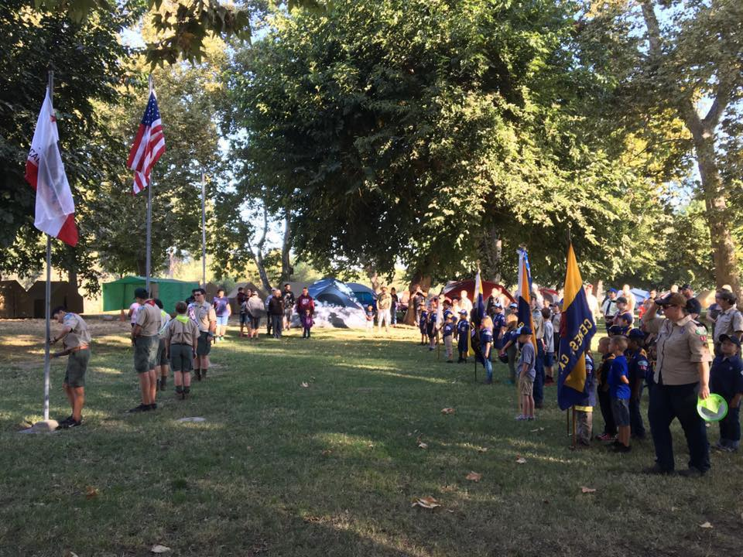

Please also consider a one-time gift above your annual gift for a minimum of $1,000 which you can designate to help sustain, grow and invest in our youth in these ways:
*Grow our Endowment
*Grow our Capital Fund
* Increase Membership & Program Participation

Our Scouts depend on your annual gift so this is
suggested above and beyond your annual gift.

