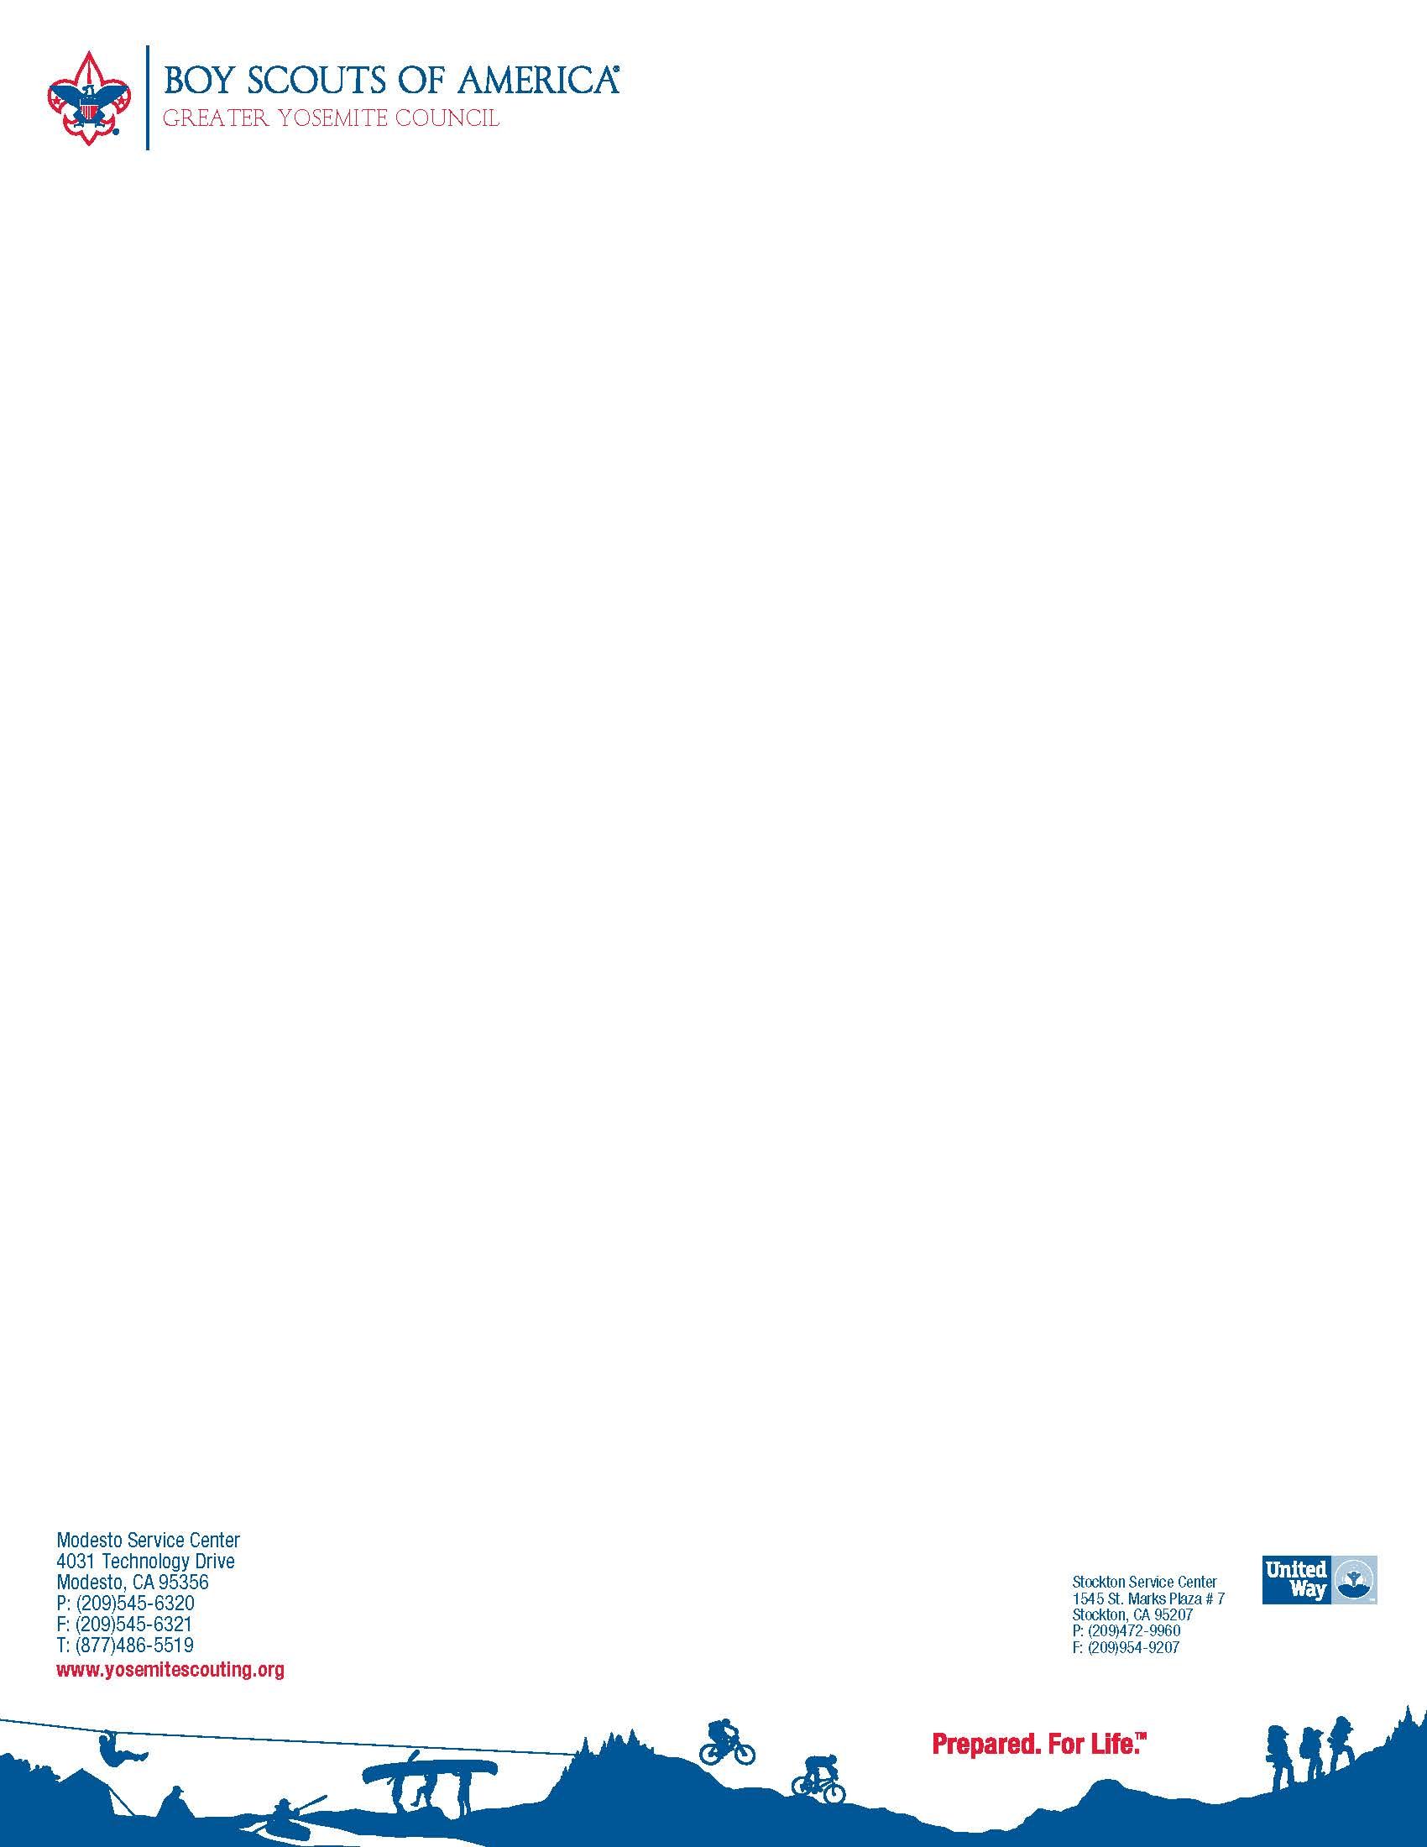

[Insert or attach photo]

Eagle Scout Name_________________

_________________________- , _________________ a member of the Boy   
 {City, State, Date} {Name}

Scout Troop_________ and a resident of ___________, has earned the honor of   
 {number} {City}  
Eagle Scout, the highest rank that the Boy Scouts offers. Only 3 to 4 percent of Boy Scout members ever attain this prestigious honor.

___________, ____, of _____________, achieved ______ merit badges required   
 {Name} {age} {School} {Number}  
 to receive the Eagle Scout award.   
For his final project he ____________________________________________________________________________________________________________________________________________________________________________________________________________________________________________________________________

_________________________________________________________________

{brief description of project and the way it helped the community}.

Download editable form at [www.yosemitescouting.org](http://www.yosemitescouting.org) , 2018 Council Awards Banquet Registration.

EMAIL to [matthew.halsig@scouting.org](mailto:matthew.halsig@scouting.org) by April 1, 2018